ATAR YEAR 11 CHEMISTRY AECHE TEST 4 ORGANIC (2017)

NAME: MODEL ANSWERS

ATAR CHEMISTRY UNITS 1 & 2 - TEST 4 (2017) TIME: 50 Minutes

Organic Chemistry

PUT A CROSS (X) THROUGH THE CORRECT ANSWER.

1. | a | b | c | d |  | 8. | a | b | c | d
2. | a | b | c | d |  | 9. | a | b | c | d
3. | a | b | c | d |  | 10. | a | b | c | d
4. | a | b | c | d |  | 11. | a | b | c | d
5. | a | b | c | d |  | 12. | a | b | c | d
6. | a | b | c | d |  | 13. | a | b | c | d
7. | a | b | c | d |  | 14. | a | b | c | d
 |  |  |  |  |  | 15. | a | b | c | d

SECTION 1
/15
SECTION 2
/35
TOTAL
/50
PERCENTAGE

SECTION 2 – SHORT ANSWER

ANSWER ALL QUESTIONS IN THE SPACE PROVIDED

- Crude oil is a mixture of hydrocarbons. These are separated into useful products, such as fuels, using a process called fractional distillation. Petrol is a mixture that includes alkanes of chain length C₅ to C₁₀. It burns explosively in a car engine to provide energy. (4 Marks)

  - Write an equation for the complete combustion of heptane. [2 marks]

C₇H₁₆ + 11O₂ 7CO₂ + 8H₂O

1 mark correct R and P, 1 mark balanced

  - Heptane is known as a saturated hydrocarbon. What does this mean? [1 mark]

Only single bonds between carbons
(No double or triple bonds between carbons)

  - Benzene is an aromatic hydrocarbon. Benzene is an unusual chemical because it does not react as expected. How does benzene react differently to other unsaturated hydrocarbons
[1 mark]

It doesn’t undergo addition reactions, substitution only

- Write balanced equations for the following if there is a reaction. If there is no reaction, write “no reaction”. Draw all organic compounds in the equations as expanded structural formulae. (5 marks)

- Bromine gas is mixed with propane and the mixture is exposed to ultra violet light for several hours.

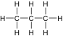
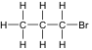
light

+ Br₂ HBr +
½ mark R, 1 mark products, ½ mark “light”

- Chlorine is mixed with but-1-ene and the mixture is placed in a dark cupboard

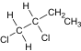
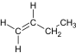

+ Cl₂

1 mark R, 1 mark P

- Bromine is mixed with ethane and the mixture is placed in a dark cupboard

No reaction 1 mark

States not required
- Draw expanded structural formulae for the following compounds. (8 marks)

a. cis-pent-2-ene b. 2-methylhex-2-ene
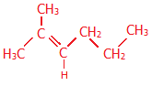
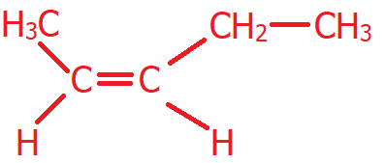

c. methylcyclobutane d. 3-ethylhept-1-ene
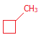
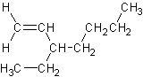

e. 2,3-dimethylpent-2-ene f. 1-ethyl-2,3-dimethylbenzene

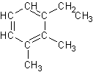
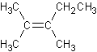

g. 1,1-dibromo-2,2-difluoroethene h. trans-2,5-dimethylhex-3-ene

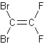

1 mark each, no half marks

- Name the following compounds using the IUPAC system of nomenclature: (8 marks)
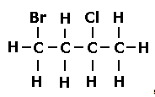
a. b.
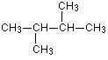

2,3-dimethylbutane 1-bromo-3-chlorobutane

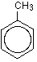
c. d.
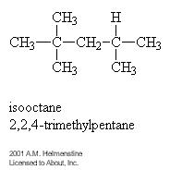

Methylbenzene 2,2,4-trimethylpentane

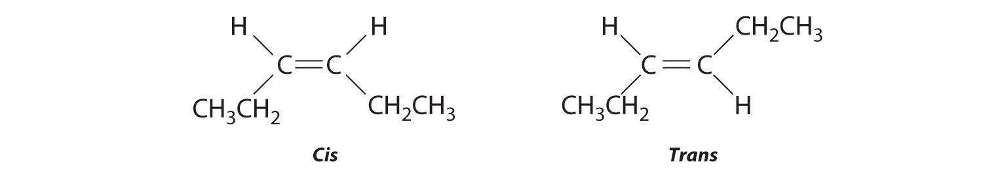
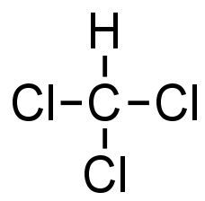
e. f.

trichloromethane cishex-3-ene

g. h.
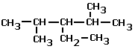
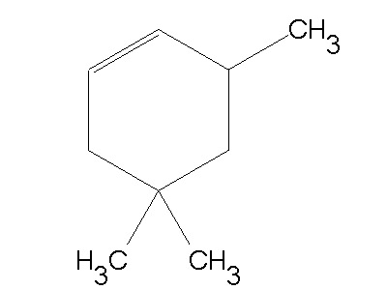

3,5,5-trimethylcyclohexene 3-ethyl-2,4-dimethylpentane

- A straight chain hydrocarbon has a molar mass of 86 gmol⁻¹ (6 Marks)

  - What family of alkanes, alkenes, alkynes or aromatics does this hydrocarbon belong to? [1 mark]

Alkanes

  - Draw and name (IUPAC) two isomers of this hydrocarbon. [4 marks]

C₆H₁₄

Two suitable isomers – 1 mark each
Correctly named – 1 mark each

  - What type of isomers are these? [1 mark]

Structural

- A student combusts a sample of propane gas in limited oxygen to produce carbon and water only. (5 marks)

  - Write a balanced equation for the reaction that occurred. [1 mark]

C₃H₈ + 2O₂ 3C + 4H₂O

  - What mass of carbon would be formed if 6.05 g of propane was burnt? [4 marks]

n(C₃H₈) = m/M ½ mark M(C₃H₈) = 3(12.01) + 8(1.008) = 44.094g
= 6.05/44.094 1 mark
= 0.1372 mol ½ mark

C : C₃H₈
3 : 1
n(C) = 3 x n(C₃H₈) ½ mark
= 3 x 0.1372
= 0.4116 mol ½ mark

m(C) = n x M ½ mark
= 0.4116 x 12.01
= 4.94 g ½ mark
END OF TEST



AECHE UNITS 1 & 2

YEAR 11 CHEMISTRY

TEST 4

Organic Chemistry

MULTIPLE CHOICE SECTION

DO NOT WRITE ON THIS BOOKLET

PLEASE DO NOT TURN THE PAGE UNTIL INSTRUCTED TO DO SO

Time Allowed: 50 minutes

SECTION 1 – MULTIPLE CHOICE QUESTIONS

- The structure drawn represents one of the isomers of formula C₂H₂Br₂.

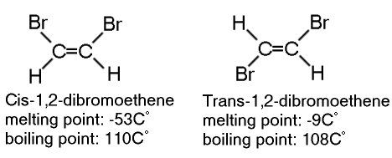

What is the total number of isomers possible for C₂H₂Br₂?

  - 1
  - 2
  - 3
  - 4

- A molecule of a non-cyclic alkane contains 9 carbon atoms. The number of hydrogen atoms in this molecule is:

  - 18
  - 19
  - 16
  - 20

- Which of the following compounds is unsaturated?

  - CH₂CH₂
  - CH₃CH₂CH₃
  - C₆H₁₄
  - (CH₃)₃CH

- A hydrocarbon added to an orange solution of bromine turns the solution colourless quickly. The hydrocarbon is probably:

  - 2-butene
  - Methylpentane
  - Benzene
  - Cyclohexane

- Two organic compounds are structural isomers of each other if they:

  - Have the same molecular formula but different structural formulae.
  - Have the same structure in the solid state but different melting temperatures.
  - Differ from each other by a CH₂ unit.
  - Have the same physical properties but different molecular formulae.

- Which of the following compounds does not exist in differing structural or geometric forms?

  - C₄H₁₀
  - C₂H₄Cl₂
  - C₂H₂Cl₂
  - C₂HCl₃

- Which reactants could be used to produce 2-chlorobutane?

  - Cl₂ and cyclobutane
  - Cl₂ and CH₃CH₂CH₂CH₃
  - Cl₂ and CH₂CHCH₂CH₃
  - Cl₂ and C₄H₆

- Which of the following names of organic compounds is INCORRECT in the IUPAC system ?

  - 3-chlorobutane.
  - 3-methylpentane.
  - 2,2-dibromoethane.
  - 2-butene.

- The formula of 2,2-dimethylpropane may be written as

  - (CH₃)₂ CHCH₂CH₃
  - CH₃CH(CH₃)₂
  - CH₃C(CH₃)₃
  - (CH₃)₂ CHCH₂CH(CH₃)₂

- Which one of the following compounds is saturated?

  - CH₂CH₂
  - CH₃CHCH₂
  - C₆H₆
  - (CH₃)₃CH

- Which one of the following hydrocarbons is least likely to react with hydrogen?

  - C₆H₁₂
  - C₄H₁₀
  - C₃H₆
  - C₂H₂

- What is the correct IUPAC name for the following compound?

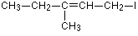

  - 4-iodo-2-ethylbut-2-ene
  - 5-iodo-3-methylpent-4-ene
  - 3-methyl-5-iodopent-3ene
  - 1-iodo-3-methylpent-2-ene

- Which of the following does not exhibit geometric isomerism?
  - Methylpropene
  - CH₃CHCHCH₃
  - CHBrCHBr
  - 2-bromobut-2-ene

- Which of the following best describes an aromatic compound?
  - Compounds having an oily odour
  - A compound with a strong odour
  - A compound containg double or triple bonds
  - Compounds that contain a benzene ring

- An Isomer of a given chemical compound, is another compound which has?

  - The same molecular weight but different chemical composition.
  - The same molecular formula but different molecular weight.
  - The same molecular formula but different physical properties.
  - The same empirical formula but a different molecular formula.

END OF SECTION 1

